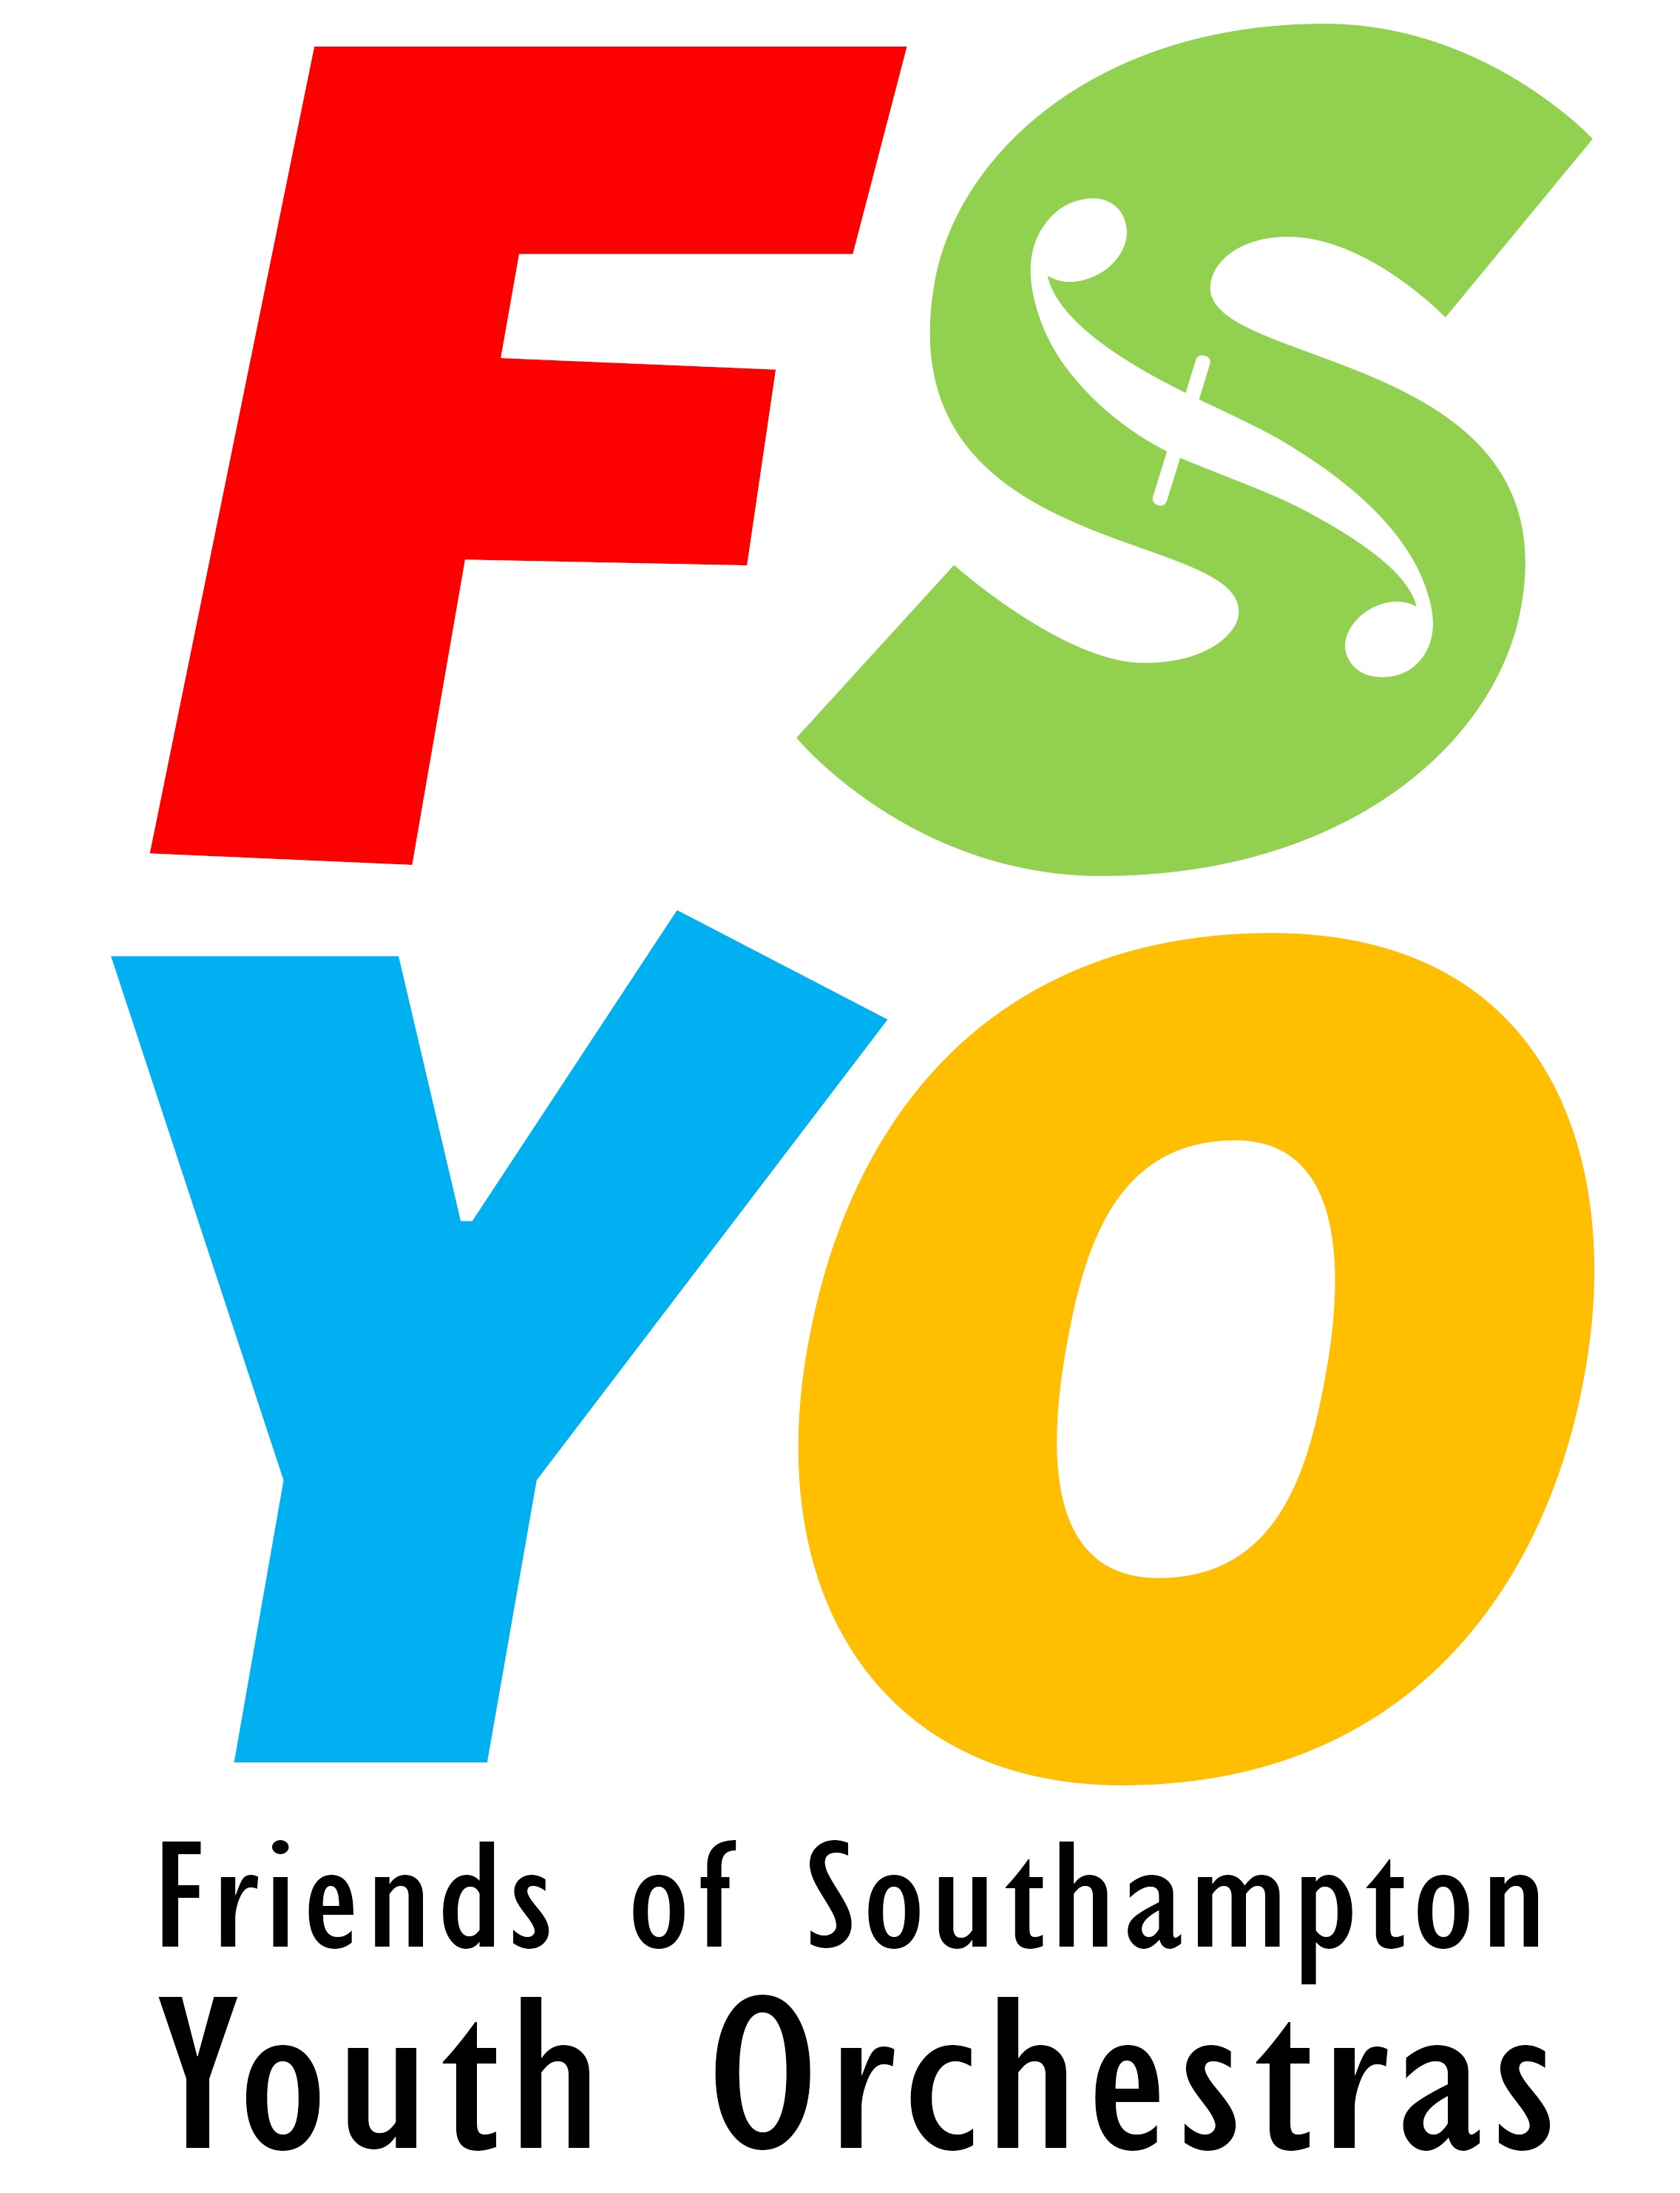
Registered Charity MEMBERSHIP FORM
No. 283789 THE FRIENDS OF THE
SOUTHAMPTON YOUTH ORCHESTRAS
Membership runs from 1st September to 31st August

The “Friends of the Southampton Youth Orchestras” is a registered charity, which supports the musical activities of five orchestras comprising some 200 young musicians from Southampton and the local area. The aims of FSYO include raising money for new music, equipment, transport, residential courses and tours; promoting orchestral activities; producing a Newsletter; maintaining a website; assisting at weekly rehearsals; assisting at concerts, including publicity and seeking sponsorship. The “Friends” help to create a stimulating environment for talented young musicians to receive coaching and develop their skills to the full.
The family of each young musician is encouraged to join the “Friends’ - and support from the wider community is welcomed, including former players and their families. Membership costs £10 per family per year and runs from 1 September to 31 August. To join the “Friends” please complete and return the form, with your payment, to the Membership Secretary. Further information is on the website: www.fsyo.org.uk or can be obtained from the Membership Secretary at the address below or email membership@fsyo.org.uk
Please return this form to: Membership Secretary, 103 Hillside Avenue, Southampton. SO18 1JZ
MEMBER DETAILS
Type of Membership: (please tick) New Renewal

Name____________________________________________________________________________________

Address __________________________________________________________________________________

__________________________________________________________________________________

_____________________________Postcode _____________________________________________

Telephone _______________________Email ____________________________________________________

ORCHESTRAL CONTACTS
Name of student Orchestra Instrument

_________________________________________________________________________________

_________________________________________________________________________________

_________________________________________________________________________________
OR: no current orchestral contact

PAYMENT (please tick)
£10 Annual Family Subscription £40 4-year Family Subscription
I enclose £ cash/ cheque (Cheques payable to FSYO please)

OR – I would like to set up a regular payment. Please send me details.

FSYO can reclaim the tax you have paid on your subscription at no extra cost to
to yourself through Gift Aid. Please tick if you are enclosing a completed Gift Aid form.
(ignore if you have completed one since January 2015)
Signed _____________________________ Date __________________
Gift Aid declaration
FRIENDS OF SOUTHAMPTON YOUTH ORCHESTRAS
Details of donor
Title ………..
Forename(s) ……………………………………………….………………………................

Surname …………………………………………………….…………………………............

Full home address…………………………………….………………………………............

…………….…………………………………………………………………………….............

…………………………………………………………………………………………..............

………………………………………………………………………………………….........…..

Post Code …………………………….….
Please treat as Gift Aid donations all qualifying gifts of money made to the Friends of Southampton Youth Orchestras in the past 4 years and all donations I make from the date of this declaration until I notify you otherwise.
I confirm I have paid or will pay an amount of Income Tax and/or Capital
Gains Tax for each tax year (6 April to 5 April) that is at least equal to the
amount of tax that all the charities or Community Amateur Sports Clubs
(CASCs) that I donate to will reclaim on my gifts for that tax year. I understand that other taxes such as VAT and Council Tax do not qualify. I understand the charity will reclaim 25p of tax on every £1 that I gave.

Signature……………………………………………………… Date………………..
Notes

You can cancel this declaration at any time by notifying the Treasurer of the Friends of Southampton Youth Orchestras.
If in the future your circumstances change and you no longer pay sufficient tax on your income and/or capital gains, you can cancel your declaration (see above).
If you pay Income Tax at the higher or additional rate and want to receive the additional tax relief due to you, you must include all your Gift Aid donations on your Self-Assessment tax return or ask HM Revenue and Customs to adjust your tax code
If you are unsure whether your donations qualify for Gift Aid tax relief, please contact HMRC
Please notify the Friends of Southampton Youth Orchestras if you change your name or address.

Modified Nov 17

